# Redis with Spring Boot

<https://www.youtube.com/watch?v=RCBwSry6Koo>

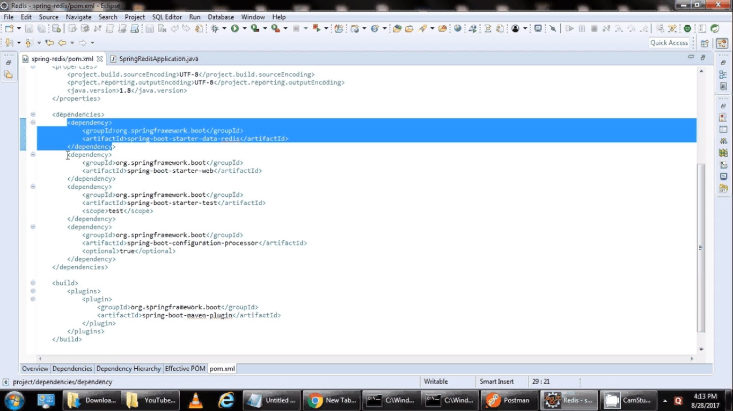

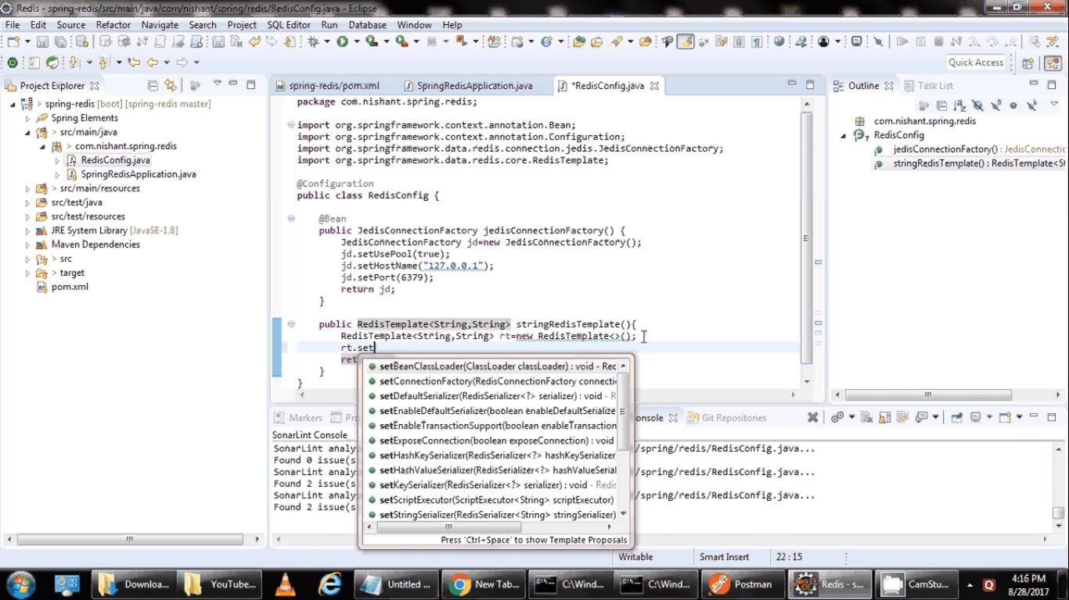

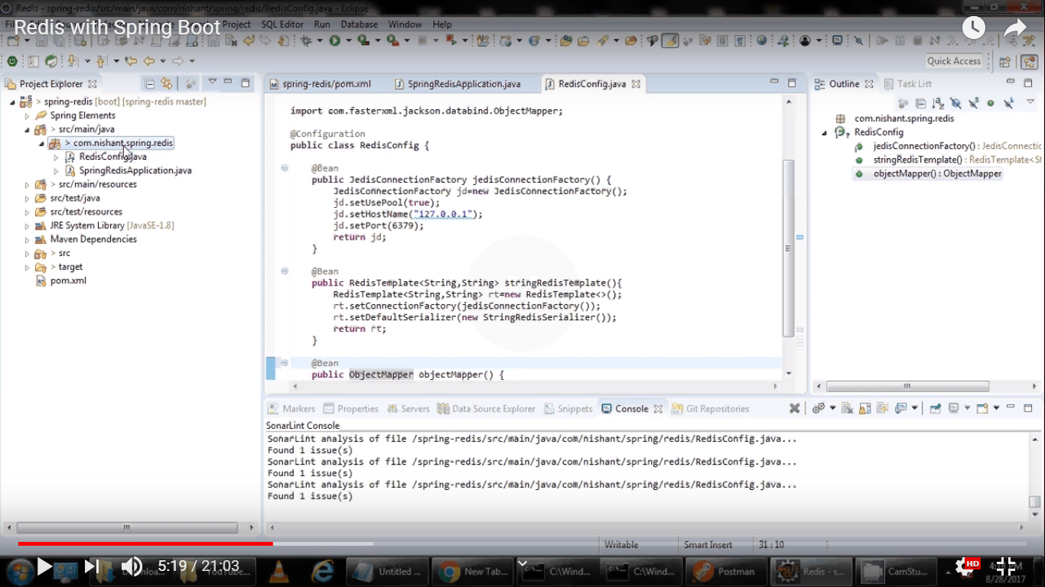

Create getters/setters and toString()

